Synoptic Meteorology I

**Lab 4: Evaluating Advection**

Wednesday September 28th, 2022

Name:­­­­­­­ ________________________________________________________________

Due: October 5th, 2022, at 2:30pm

**Objectives:**

* Qualitatively evaluate horizontal temperature advection via using isotherms and horizontal winds and the cherries/berries method.
* Quantitatively evaluate horizontal temperature advection using finite differencing.
* Infer the relationship between horizontal temperature advection and vertical motions using satellite imagery.
* Learn how to plot objectively analyzed data in Python.

**Things to know:**

Feel free to use the Internet and collaborate with your colleagues when answering these questions. ForParts I, II, and III, the requested data and plots must be obtained using the Jupyter Notebook on our JupyterHub before you can complete the questions. Be sure to review the concepts covered in this tutorial rather than just complete the tasks it requires as you may be asked to use these concepts in a future lab.

**Part I: Temperature Gradients (20 pts)**

When looking for areas of horizontal temperature advection, we first need to identify horizontal temperature gradients. A gradient is a change in some quantity over a given distance. From calculus, the symbol for gradient is $∇$ and when combined with temperature (*T*), we have temperature gradient ($∇T)$. The following equation describes the horizontal temperature gradient in component (rather than vector) form:

$$∇_{H}T= \frac{∂T}{∂x}+ \frac{∂T}{∂y}$$

Looking at both terms, we can see that larger horizontal changes in temperature ( $∂T$– approximated by $∆T$) are associated with a larger horizontal temperature gradient since change in temperature is in the numerator. However, if that change is over a large distance ( $∂x$ or $∂y$– approximated by $∆x$ or $∆y$), the horizontal temperature gradient will not be as large due to the denominator being larger. Thus, to get large temperature gradients you need both large horizontal changes of temperature over a short distance, whereas to get small temperature gradients you need both small horizontal temperature changes over a large distance.

1. Complete Part I in the Jupyter Notebook tutorial. (5 pts)
2. Using the 850 hPa map for November 10th, 2021 that you created in the Jupyter Notebook tutorial’s Part I:
   1. With a solid black line, outline one region with a large horizontal temperature gradient magnitude. (4 pts)
   2. With a dashed black line, outline one region with a small horizontal temperature gradient magnitude. (4 pts)
   3. Briefly explain why you chose each region. (7 pts)

**Part II: Horizontal Temperature Advection (55 pts)**

Now that we know how to find horizontal temperature gradients, we can use the wind to find horizontal temperature advection. The dot product is used to describe horizontal temperature advection:

$$-V_{H} ⋅ ∇_{H}T$$

In its expanded (component) form, the expression in Cartesian coordinates becomes:

$$-u\frac{∂T}{∂x}-v\frac{∂T}{∂y}$$

The first and second terms represent temperature advection in the *x*- and *y*- directions, respectively. Positive values of horizontal temperature advection are associated with warm-air advection, whereas negative values of horizontal temperature advection are associated with cold-air advection.

But when assessing horizontal temperature advection on maps, Cartesian coordinates can be troublesome. By using *natural* coordinates, however, assessing horizontal temperature advection is made easier. The following equation is for horizontal temperature advection in natural coordinates:

$$-V\frac{∂T}{∂s}$$

*V* is the wind speed and $\frac{∂T}{∂s}$ is the change in temperature along the *s-*, or streamwise (i.e., along the wind or following the motion), axis.

1. Using the 850 hPa map for November 10th, 2021 that you created in the Jupyter Notebook tutorial’s Part I:
   1. In natural coordinates, with a bold, blue line, circle a region of strong cold-air advection (CAA). (3 pts)
   2. In natural coordinates, with a dashed, blue line, circle a region of weak cold air advection.
   3. Briefly explain why you chose each region.
   4. In Cartesian coordinates, use centered finite differences to calculate horizontal temperature advection for the region of strong cold air advection you chose. To do so, center two 2-cm lines from north to south and east to west over the wind barb (indicate which wind barb used). (The distance between the northern border and southern border of North Dakota is 340 km, isotherms are every 2°C, and 1 kt = 0.5 m/s). Show all work and units.
   5. In natural coordinates, with a bold, red line, circle a region of strong warm air advection (WAA). (3 pts)
   6. In natural coordinates, with a dashed, red line, circle a region of weak warm air advection. (3 pts)
   7. In Cartesian coordinates, use centered finite differences to calculate horizontal temperature advection for the region of strong warm air advection you chose. To do so, center two 2 cm lines from north to south and east to west over the wind barb (indicate which wind barb used). Use a time of 2 hours. (The distance between the northern border and southern border of North Dakota is 340 km, isotherms are every 2°C, and 1 knot = 0.5 m/s). Show all work and units.
2. Using the 850 hPa map below, explain why large horizontal temperature advection (either positive, for warm-air advection, or negative, for cold-air advection) is or is not happening at each point. (4 pts each)

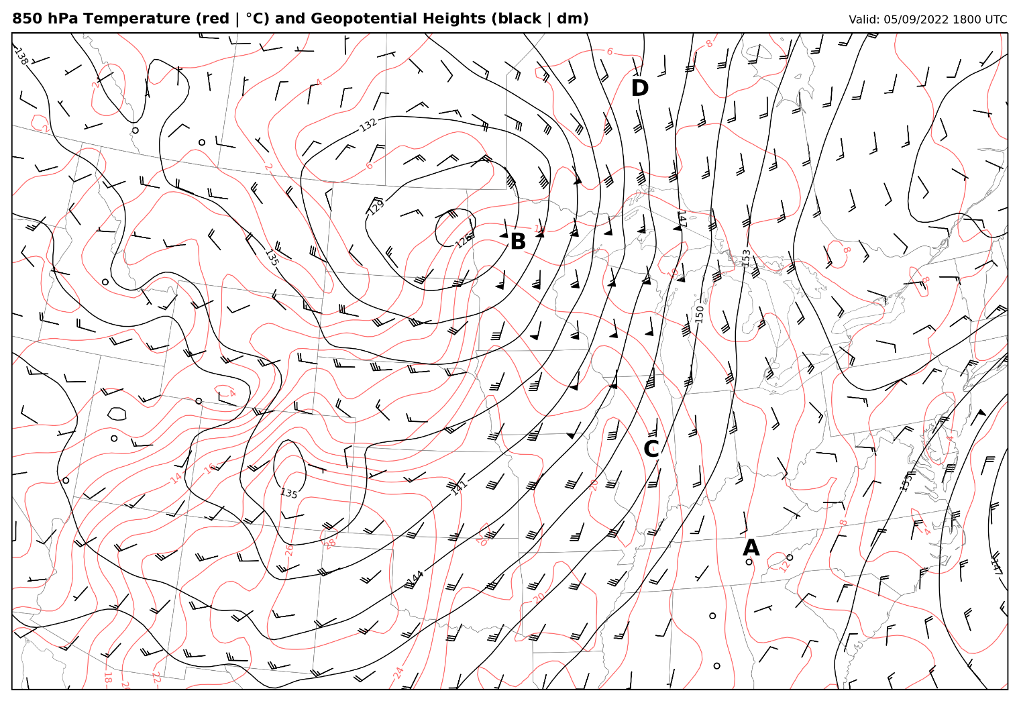

**Part III: Horizontal Temperature Advection and Vertical Motion (25 pts)**

Even though we have not learned yet what causes vertical motion, we can expand on our knowledge of horizontal temperature advection to gain some preliminary insights. Using the attached figures, answer the following questions.

1. Complete Part II in the Jupyter Notebook tutorial (5 pts)
2. Using the 850 hPa map for April 7th, 2021 that you created in Part I of the Jupyter Notebook tutorial, circle the region of strongest cold-air advection in the US. Compare this to the same region on the satellite image you created in Part II of the Jupyter Notebook tutorial. What is happening here? What can you infer the overall vertical motion to be? (10 pts)
3. Using the 850 hPa map for April 7th, 2021 that you created in Part I of the Jupyter Notebook tutorial, circle the region of strongest warm-air advection. Compare this to the same region on the satellite image you created in Part II of the Jupyter Notebook tutorial. What is happening here? What can you infer the overall vertical motion to be? (10 pts)

**Part IV: Cherries and Berries Method (10 pts)**

The "cherries and berries" method is a qualitative way of evaluating horizontal temperature advection from synoptic charts, particularly in the lower-to-middle troposphere above the planetary boundary layer where the wind tends to be geostrophic (and thus tends to blow parallel to isobars/isohypses). The "cherries and berries” method uses this information to assess horizontal temperature advection, with a cherry (or red dot, signifying warm-air advection) placed at the intersection of isobars/isohypses and isotherms where the wind blows from warm toward cold air and a berry (or blue dot, signifying cold-air advection) placed at intersections of isobars/isohypses and isotherms where the wind blows from cold toward warm air.

1. With arrows pointing in the direction that the wind is blowing *towards*, indicate the wind direction at points A, B, and C on the chart below. (4 pts)
2. Identify whether A/B/C is a cherry or a berry by coloring in the circle with red or blue, respectively. (6 pts)

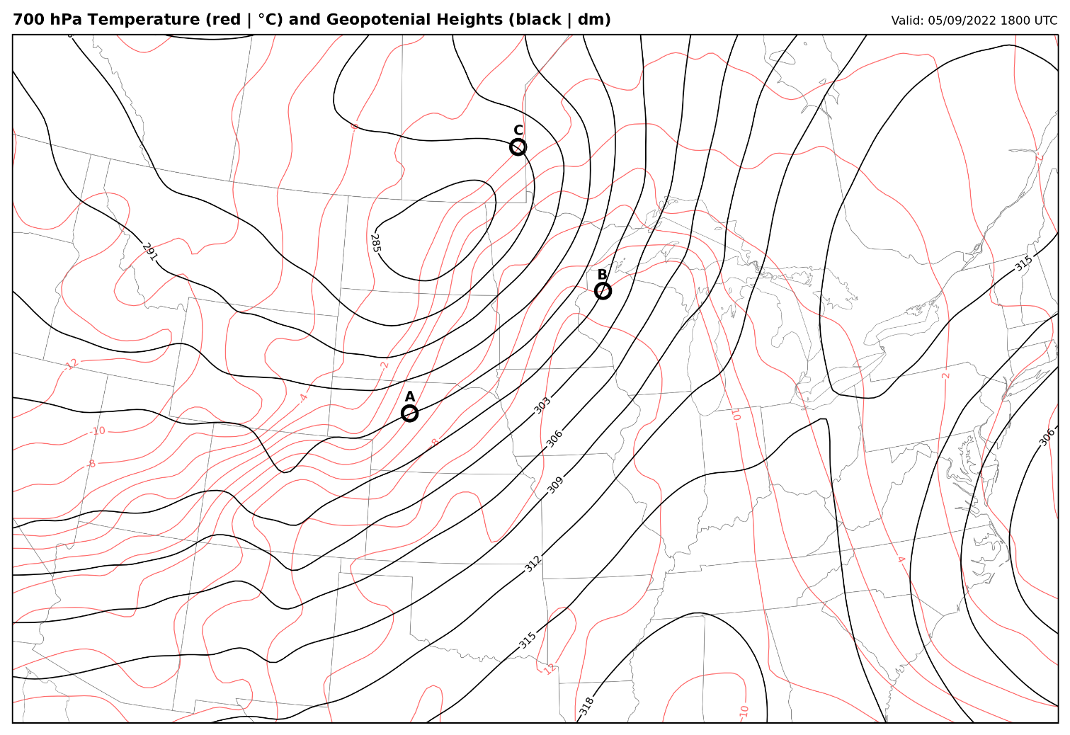

**Part V: Calculating Temperature Change from Horizontal Temperature Advection (Graduate Students Only; 10 pts)**

1. In Cartesian coordinates, use centered finite differences to calculate horizontal temperature advection for point B in the map for question 4. (The distance between the northern border and southern border of North Dakota is 340 km, isotherms are every 2°C, and 1 kt = 0.5 m/s). Show all work and units. (3 pts)
2. Based on your answer to question 10, over a 2-h period, how much will the temperature change due solely to horizontal temperature advection? Show all work and units. (3 pts)
3. Below are the closest METAR observations near point B at 1800 UTC and 2000 UTC. How does the observations match your answer to question 11? If the observations are different from the values calculated, hypothesize as to why the observations may be different. (4 pts)

*KBJI 091755Z AUTO 15018G28KT 4SM -DZ OVC008 12/12 A2927 RMK AO2 LTG DSNT NW THRU NE 60044 T01210121 10121 20091 P0003*

*KBJI 091955Z AUTO 16021G29KT 5SM BR OVC008 14/14 A2925 RMK AO2 T01370137*